Task 4

**Step1**:

Control Panel > System and Security > Windows Defender Firewall

**Step 2:**

Open Powershell or command promt > run as administrator

**Step 3:**

Listing current firewall rules in **Powershell** using commands:

**“Get-NetFirewallRule”**

“we will get all the firewall rules that are present in our systems based on our applications downloaded”

**Step 4:**

Rule to block inbound traffic on a specific port 23

Command:**”** **New-NetFirewallRule -DisplayName "Block Telnet" -Direction Inbound -LocalPort 23 -Protocol TCP -Action Block”**

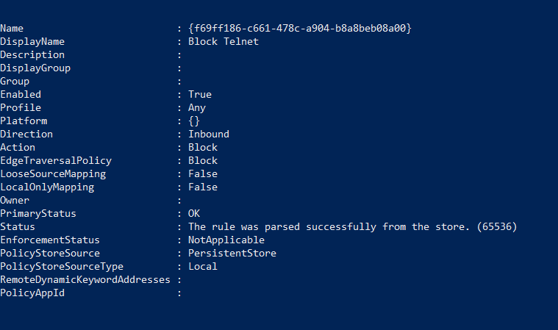

Step 5:

Test the rule added

Command: **“Test-NetConnection -Port 23 -ComputerName localhost”**

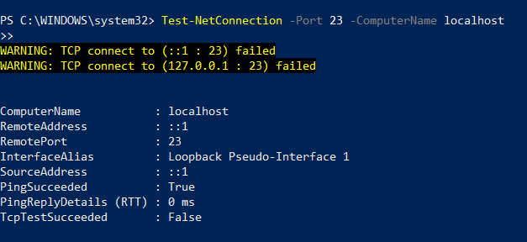

Step 6:

Remove the Test Block Rule:

Command: **“Remove-NetFirewallRule -DisplayName "Block Telnet””**